Nexora workspace navigation and theme
Document 3 of the Nexora learning guides
Source snapshot 13 October 2026 at 17:12 UTC
Find the shared sidebar, header, logo, responsive menu and staff workspace colours.

Recognise the screen and its scope
Open /dashboard, /relationships, /settings. CRM routes use port 3017; member routes use 3018; public website routes can use 3019. Brackets name a route parameter, not text to paste into a browser. Choose a real record or site id from the application.
This guide covers Navigation groups and submenu links; Mobile menu; User account and sign-out; Permission-filtered navigation; Shared neon theme and headings.
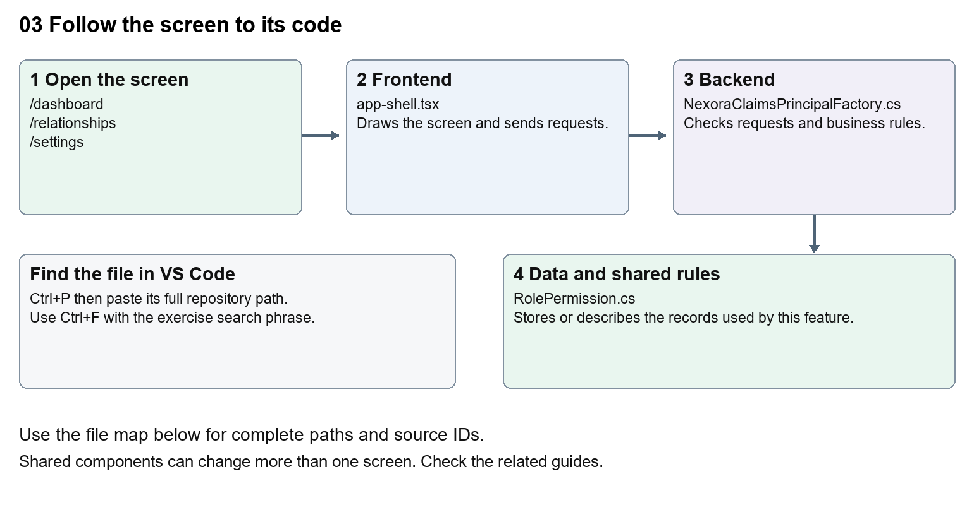
The diagram shows the file roles. The full paths below are what you paste into Ctrl+P.

Find the files in VS Code
Role | File and source ID | What it does
Screen | S0058 app-shell.tsx | Main UI or route for this topic
Server | S0408 NexoraClaimsPrincipalFactory.cs | Endpoints or server rules
Data | S0378 RolePermission.cs | Data shape or persistence structure

Screen S0058
apps/web/src/components/app-shell/app-shell.tsx
Server S0408
backend/src/Modules/Nexora.Modules.Identity/Security/NexoraClaimsPrincipalFactory.cs
Data S0378
backend/src/Modules/Nexora.Modules.Identity/Domain/RolePermission.cs
The complete HTML manual opens these source IDs inside its Source library. The Word manual shows short labelled extracts so you can learn the flow before reading large files. Each individual Markdown guide includes its complete primary files after the walkthrough.

Follow the request and the records
1. The protected platform layout obtains a staff session.
2. AppShell receives the display name and permissions.
3. The navigation array supplies labels, routes and icons.
4. Permission filtering hides unavailable groups.
5. The selected route becomes the page content inside the shared shell.

Read the code with an explanation
The shell surrounds many CRM pages. Changing a sidebar label changes every page using that shell. A hidden menu does not secure the API; server authorisation still checks every protected request. Specific routes take precedence over the old [workspace] placeholder route, which still displays a Scheduled module message for its recognised fallback names.
Source reference S0058 apps/web/src/components/app-shell/app-shell.tsx
Selected opening lines with their original numbers. The complete file is in the HTML source library.
0001 "use client";
0003 import Link from "next/link";
0004 import type { Route } from "next";
0005 import { usePathname } from "next/navigation";
0006 import { useRouter } from "next/navigation";
0007 import { useRef, useState, type ReactNode } from "react";

The import lines lead to shared components and helpers. Start at the exported component or route function; follow the request helper to the server rather than assuming the whole feature lives in this file.
Source reference S0408 backend/src/Modules/Nexora.Modules.Identity/Security/NexoraClaimsPrincipalFactory.cs
Selected opening lines with their original numbers. The complete file is in the HTML source library.
0001 using System.Security.Claims;
0002 using Microsoft.AspNetCore.Identity;
0003 using Microsoft.EntityFrameworkCore;
0004 using Microsoft.Extensions.Options;
0005 using Nexora.Modules.Identity.Domain;
0006 using Nexora.Modules.Identity.Infrastructure.Persistence;

On the server, look for MapGet to load records, MapPost to create or perform an action, MapPut or MapPatch to change data, and RequireAuthorization for permissions. Some shared methods register endpoints indirectly. Find SaveChangesAsync to see the database write. A request method alone does not tell you every side effect.
Source reference S0378 backend/src/Modules/Nexora.Modules.Identity/Domain/RolePermission.cs
Selected opening lines with their original numbers. The complete file is in the HTML source library.
0001 namespace Nexora.Modules.Identity.Domain;
0003 public sealed class RolePermission
0004 {
0005 public Guid RoleId { get; set; }
0006 public NexoraRole Role { get; set; } = null!;
0007 public required string Permission { get; set; }

Follow model fields to their request names and database mapping. An id points to a particular record. A tenant id limits the organisation. A version or concurrency stamp protects newer edits. Some model files describe contracts rather than tables; check the owning DbContext before assuming storage.

Make or trace your first change
1. Press Ctrl+P and open apps/web/src/components/app-shell/app-shell.tsx.
2. Press Ctrl+F and search for Workspace</p>. In this snapshot it appears at line 74.
3. Change the small sidebar heading only. Keep the closing tag and class names. Refresh CRM and verify two different pages show the same changed heading.
4. Replace only Workspace</p> with Nexora workspace</p> in that intended location. Keep quotes, tags, JSON keys and routes intact.
5. Save with Ctrl+S. Inspect Problems and the local screen. Review the diff and restore the original text when you finish practising.
Extract from source line 74. A fragment from a long line is shown without the rest of that line.
0074 <p className="mb-2 px-3 text-[10px] font-semibold uppercase tracking-[0.14em] text-[#a0a9b8]">Workspace</p>

These exercises have not been applied to the application. Their search phrases are verified against the captured source. Line numbers can move; the phrase and file path are your main navigation aids.

Check a change and diagnose problems
Confirm the original screen still loads, the changed words appear in the intended place, and another screen using the same component still behaves correctly. If an action fails, inspect the browser Network response, the relevant helper and server validation message. Use the common error table at the beginning of the manual. Reload on a version conflict instead of removing the version check.
A syntax error after a text edit usually means a quote, brace or closing tag changed. Compare your diff with the original. An unchanged browser result can mean the wrong port, a saved published configuration overriding a default, or a running API that has not reloaded.

Understand the current limits
The staff shell and staff login appearance are source-controlled. Portal and website presentation settings have their own CRM-managed controls. Do not describe staff theme CSS as a stored per-tenant setting.

Continue learning
Related guides 07 Nexora record listings and saved views, 20 Nexora administration and access, 26 Nexora portal management, 27 Nexora website editor and publishing.

